1st International Space Symposium: A New Space for Mauritius
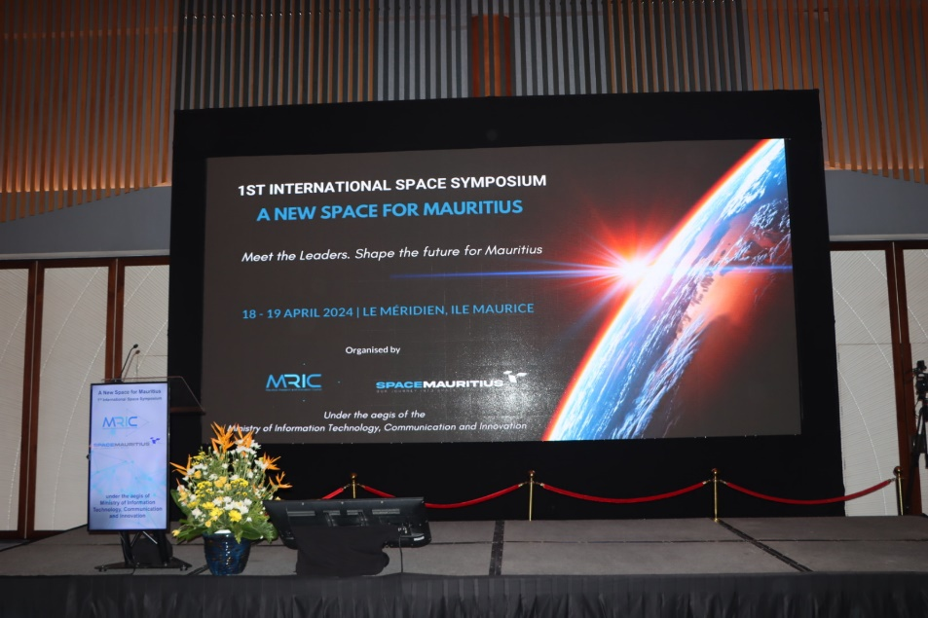
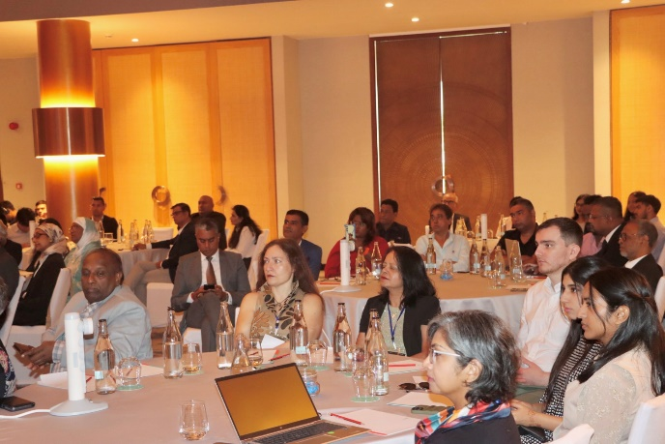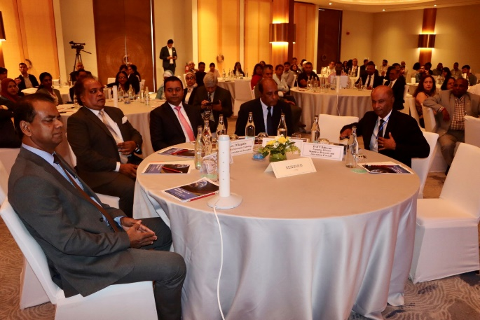
In pursuit of our vision to making space our next Socioeconomic pillar, the MRIC in collaboration with the Ministry of Information Technology Communication and Innovation, organised the 1st International Space Symposium held on the 18th and 19th April 2024 at the Le Méridien Ile Maurice. the theme of the symposium was a New Space for Mauritius.
The aim of the symposium was to seek and solicit inputs from the expertise of diverse local and international experts. This Symposium augured as an open discussion platform to push the Mauritian Space Agenda forward by tapping into the expertise of internationally renowned space and satellite technology experts and thought leaders together with key Mauritian stakeholders from the public sector, private sector, academia, and the society. International experts from UK, Japan, Germany, South Africa, India, Uganda, Switzerland and France were among the participants.
The experts examined the following themes:
- Downstream applications of satellite data
- R&D and capacity building in space and satellite technologies
- Regulatory considerations for new space for Mauritius
- Space and Business for Mauritius
Through engaging discussions, insightful presentations, and collaborative workshops, the collective expertise and resources were leveraged to foster a deeper understanding of the possibilities and challenges associated with integrating space technologies into national development agenda of the Republic of Mauritius. Moreover, the Symposium on New Space for Mauritius provided a unique opportunity for networking and forging partnerships that can propel the participating local institutions into the forefront of the space domain to unlock the full potential of space-based applications.
The outcomes of the symposium provided key insights for the MRIC to draft a roadmap for further development of the Space and Satellite Technology for Mauritius.
India Mauritius Joint Satellite
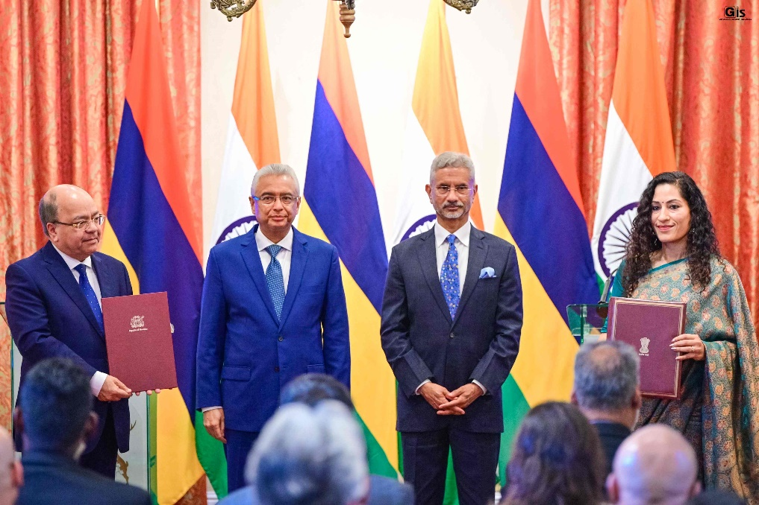
(source https://govmu.org/EN/Pages/NewsDetails.aspx?n=PM-Jugnauth-and-Indian-EAM-Dr-Jaishankar-renew-bilateral-ties-through-exchange-of-MoU-and-e-inauguration-of-co.aspx)
On the 1st November 2023 the MRIC signed an MoU with ISRO for the implementation of the India Mauritius Joint Satellite (IMJS). Following around 6 months of technical discussions between ISRO and MRIC engineers, the specifications of the IMJS have been finalised. The Project Plan Agreement, wherein all the specifications, timeline and technical details have been laid out, has been signed by both parties and exchanged in a ceremony held on the 16th July 2024 in presence of the Honourable Prime Minister of the Republic of Mauritius, Mr Pravind Kumar Jugnauth and Minister of External Affairs of India, Mr S. Jaishankar.

The aim of the IMJS will be as follows:
- Capacity Building for MRIC Engineers
- Using the MRIC Ground Station to support the IMJS and receive payload data directly
- Capture high resolution images in the multispectral bands.

The main attributes of the IMJS are listed below:
- The mass of the satellite will be 18.5kg and the dimension will be 415 x465x500mm in stowed configuration and 1051x465x500mm with the solar panel deployed.
- The satellite will be placed in a sun synchronous polar orbit at an altitude of 475km.
- A multispectral payload with a three mirror anastigmat configuration will be used. The spatial resolution will be of 11-15m which means it can capture object of size at least 11m to 15m.
- The swath of the satellite will be 65km, that is it will scan a width of 65km during each pass.
- The priorities areas for satellite image capture (Mauritius main island, Rodrigues Island and Agalega Island).
- The Design Mission Life of the satellite is 6 months.

NEREUS
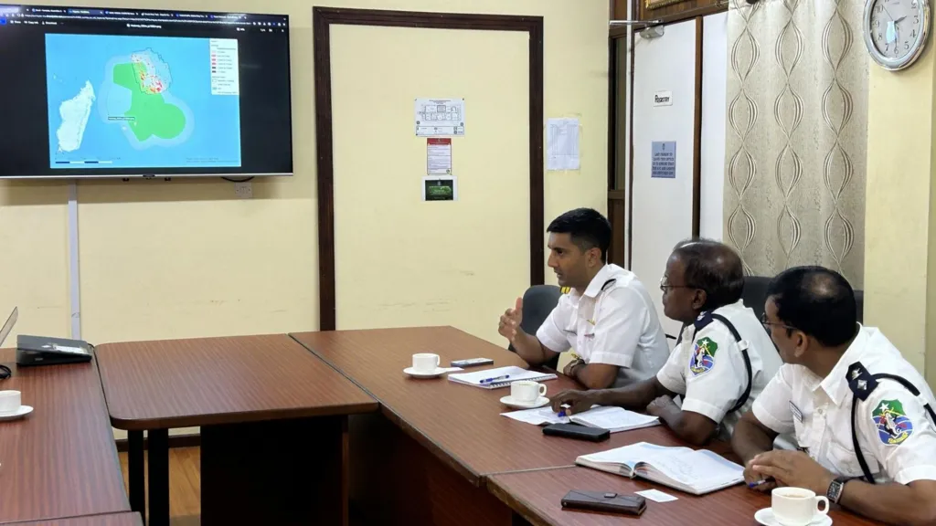
(source https://www.bbc.com/news/articles/c0v04e1jj09o)
The NEREUS project, led by the Surrey Space Centre (SSC) in collaboration with the Mauritius Research and Innovation Council (MRIC), aimed at developing a tool, which uses maritime navigation data, satellite data and machine learning techniques to monitor fishing vessels in the Mauritius Exclusive Economic Zone (EEZ). The innovative nature of the project and the pertinence of its objectives enabled the SSC and MRIC to be awarded funding under the United Nation Development Programme’s Ocean Innovation Challenge scheme (UNDP OIC), 2nd call: Sustainable Fisheries. The key application for this tool is the detection of potential Illegal, Unreported and Unregulated (IUU) fishing activities, to improve sustainable management of marine resources.
The development of the algorithmic tool comprised the following steps:
- The generation of Automatic Identification System (AIS) based maps of fishing vessels. The studies and these maps allow characterising the fishing vessels and their mode of operations precisely. This is important for training the machine learning algorithm.
- Using AIS and SAR data, the NEREUS workflow computes assignments, that is, vessels detected in satellite SAR images without a corresponding signature in the AIS data.
- With such an analysis over a long interval of time and training the NEREUS algorithm with context data such as MPAs and the boundaries of the EEZ, the workflow generates dark heatmaps. These maps show regions where there are high probabilities of anomalous behaviours among fishing vessels’ activities.
The above exercise gave rise to an enhanced product which consisted of a vessel trajectory prediction tool which works in near real-time. Therefore, if a fishing vessel turns off its AIS, NEREUS could predict within 1-2 hours, the trajectory which the vessel could have followed post the AIS shut-off. This is key for tackling contraveners.
A very important output of the project was an Economic Impact Report. The MRIC and SSC wish to acknowledge the collaboration of the Ministry of Blue Economy, Marine Resources, Fisheries and Shipping Minister of Fisheries in generating this report. This report firstly provides a methodology to estimate the potential economic loss due to the presence of dark vessels or non-authorized fishing vessels in the Mauritius EEZ. The development of this method followed FAO guidelines and relied on past techniques in this area.
The NEREUS is a potent tool which would enhance the existing measures undertaken by local authorities to combat Illegal, Unreported and Unregulated fishing. The project has officially been completed on the 31st of May 2024.
Prepared by Pawan Hurnath and Ziyaad Soreefan

